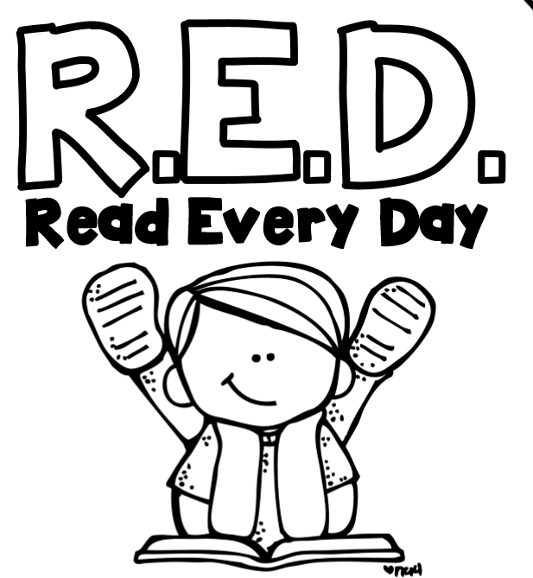

Name:

We take part in the BOOK IT! Program from Pizza Hut. BOOK IT! motivates children to read by rewarding their reading accomplishments with praise, recognition and pizza. Each month your child will be rewarded with a free personal pizza coupon when they return their competed R.E.D log.

|  |  |  |
| --- | --- | --- |
| **Title of Book** | **Date** | **Signature** |
|  |  |  |
|  |  |  |
|  |  |  |
|  |  |  |
|  |  |  |
|  |  |  |
|  |  |  |
|  |  |  |
|  |  |  |
|  |  |  |